Homework – The Central England Temperature record

Using the graph above answer the following questions;
- Which month has experienced the biggest change in temperature?
- Calculate the change for this month (subtract the smallest number from the largest number)
- Which month has experienced the smallest change in temperature?
- Calculate the change for this month (subtract the smallest number from the largest number)
- Overall what has happened to temperatures for this location in the UK over time?
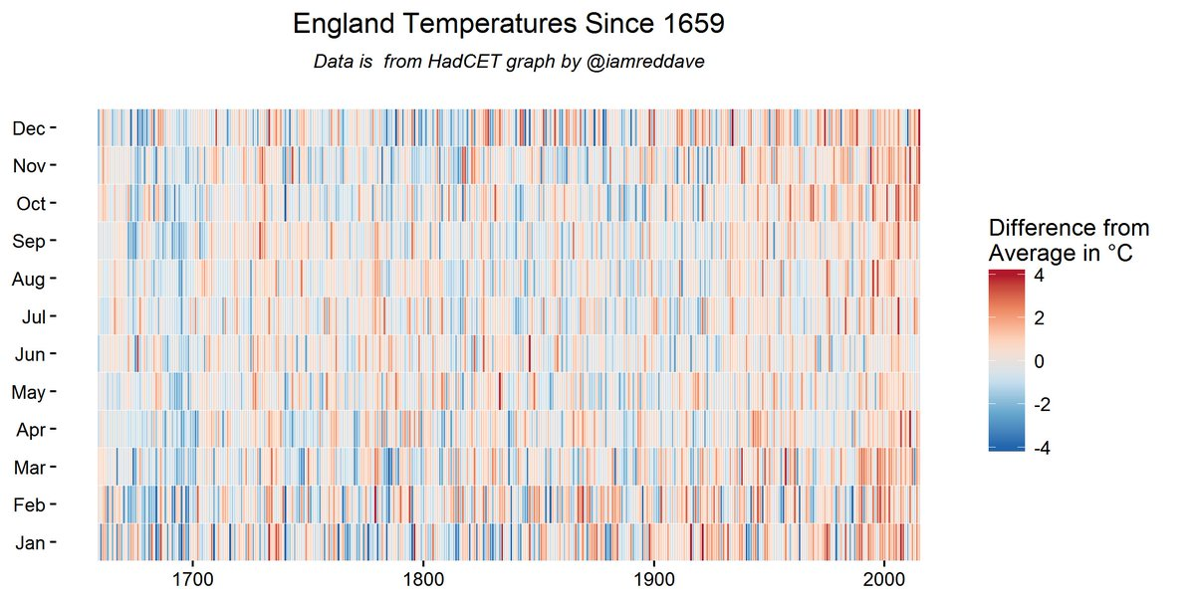
- Using the graph opposite, what has happened to temperatures over time from 1650 to the present day?
By Iamreddave - Own work, CC BY-SA 4.0, https://commons.wikimedia.org/w/index.php?curid=81925811

