Tropical Cyclones

- Describe the weather during Hurricane Dorian
- Describe the impacts of this tropical cyclone on people and the environment
- Complete the diagram below by adding each word from the box into the gaps
WORD BOX
thunderstorms Cumulonimbus Rain
26°C+ Eye wind

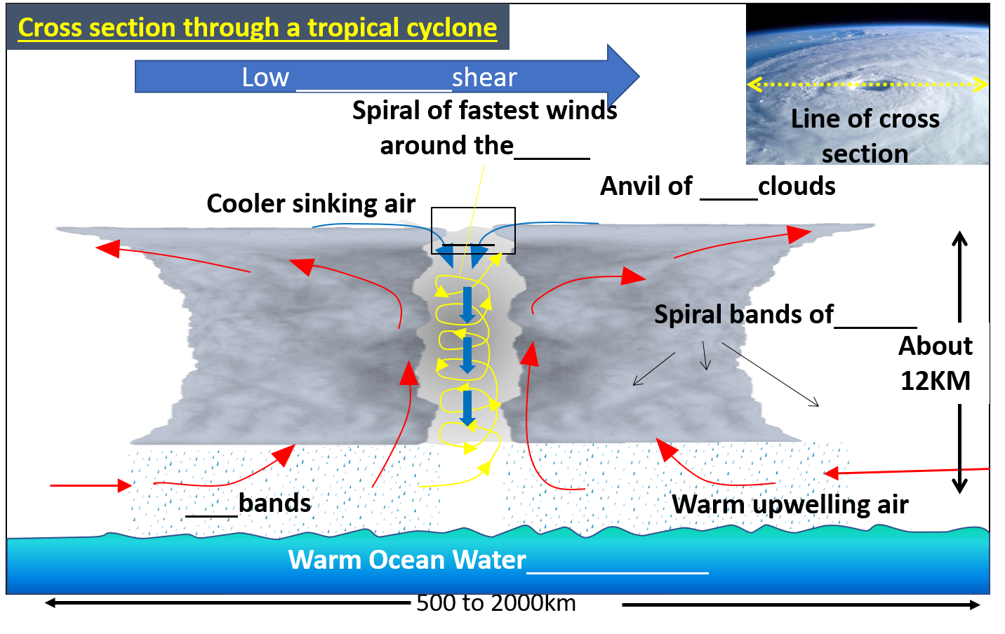
- Add some extra annotations to your cross section of a tropical cyclone diagram to explain how they form.

Describe the location of Tropical cyclones
_________________________________________________________________________________________________________________________________________________________________________________________________________________________________________________________________________________________________________________________________________________________________________________________________________________________________________

USEFUL SENTENCE STARTERS -
- Tropical cyclones are found...
- Most Tropical cyclones occur in.....
- The fewest Tropical cyclones occur.....
- Many Tropical cyclones occur at the latitudes of.....
- There are no Tropical cyclones.....
- Tropical cyclones are called …
- The countries most affected by Tropical cyclones are …
- This second map shows that we do not get Tropical cyclones between the latitudes of…

Map of major Tropical Cyclone Regions

