Weather Variables and How we Measure Them

Weather element | Instrument | Units | Image
Air pressure |  | mb (millibars)
Cloud cover | Satellite or Human sight
Precipitation | Rain gauge | mm (millimetres)
Temperature
Wind direction |  | Compass point that the wind is coming from (e.g. north) | 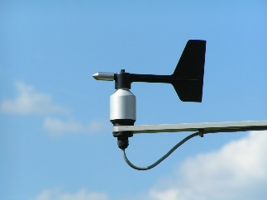
Wind speed | Anemometer | m/s or km/h (metres per second or kilometres per hour) or sometimes the Beaufort scale

Weather stations – what they are and where to place them
- Label the image of a weather station, which instrument do you think measures;
- Temperature (digital thermometer)
- Wind speed (Anemometer)
- Wind direction (Wind vane)
- Rainfall (via a rain gauge)
2. Why do you think that the thermometers are kept within a slatted screen?
3. Attempt the extension activities

Extension - What is this and why is it needed?
Extension – what do you think is held in this box?

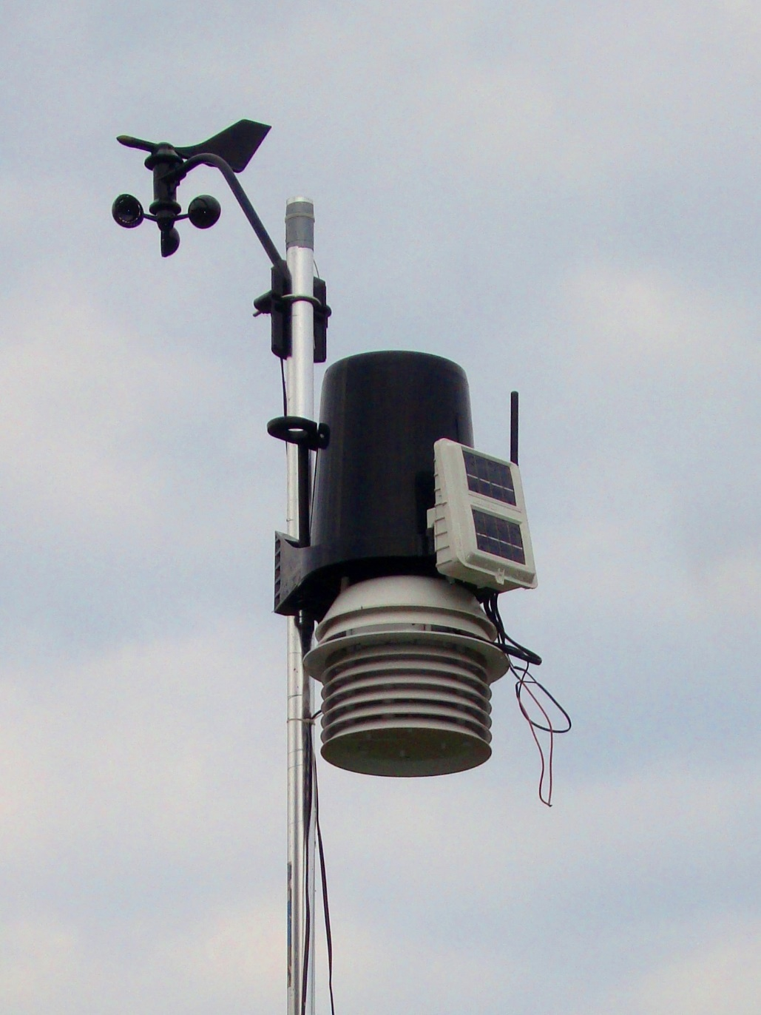

Where to place a weather station
Where would you place a weather station at Reading University and why?
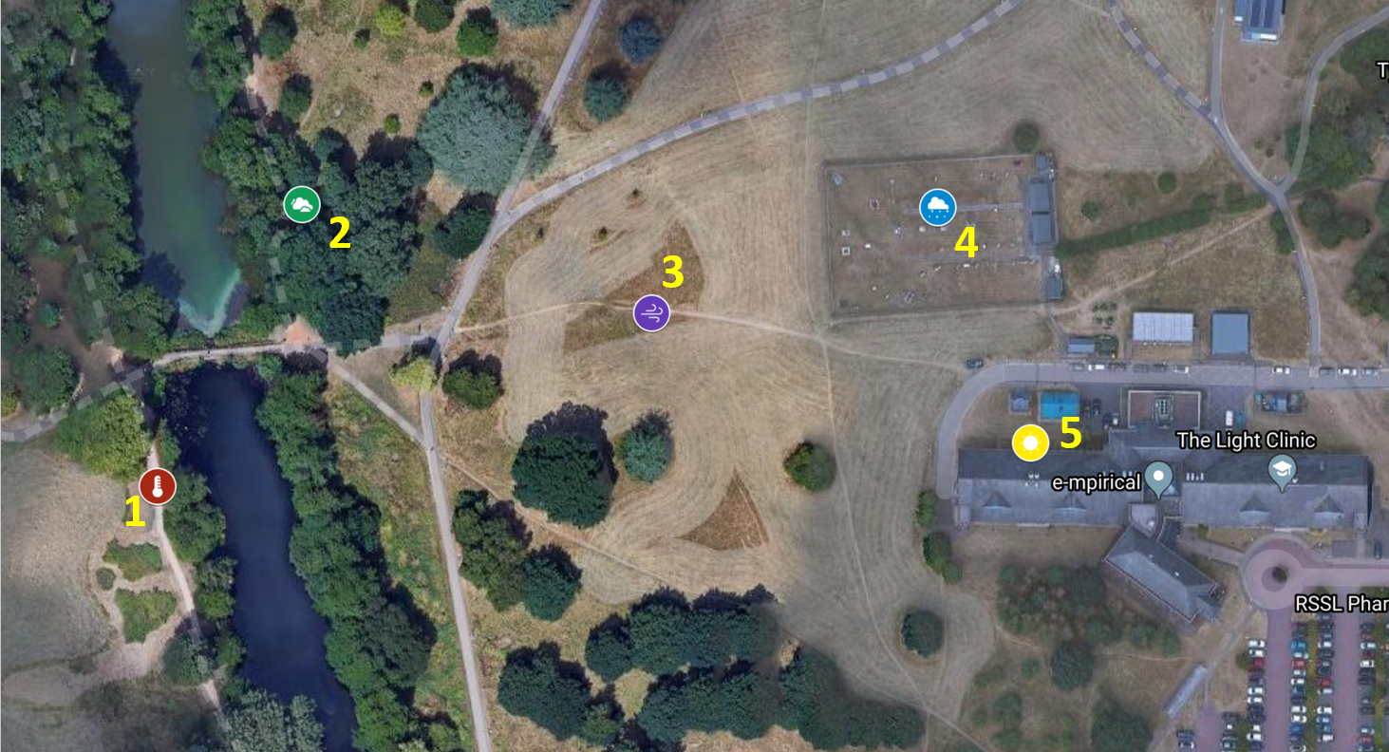
Image source: Google Maps with CNES / Airbus, Getmapping pls, Infoterra Ltd & Bluesky, Landsat / Copernicus, Maxar Technologies

Site | Level ground | No trees that influence measurements | No buildings that influence measurements | In a Frost Hollow? | Close to water source which affects humidity measurement
1 | Slightly sloping next to lake bank 3/5 | There are trees next to the lake  1/5 | None – 5/5 | No, 5/5 | Yes – the lake 1/5
2
3
4
5

I have selected site because

