Weather element | Instrument | Units | Image
Air pressure
Cloud cover
Precipitation
Temperature
Wind direction
Wind speed

Weather Variables and How we Measure Them

Weather stations – what they are and where to place them
- Label the image of a weather station, which instrument do you think measures;
- Temperature (digital thermometer)
- Wind speed (Anemometer)
- Wind direction (Wind vane)
- Rainfall (via a rain gauge)
2. Why do you think that the thermometers are kept within a slatted screen?
3. Attempt the extension activities

Extension - What is this and why is it needed?
Extension – what do you think is held in this box?

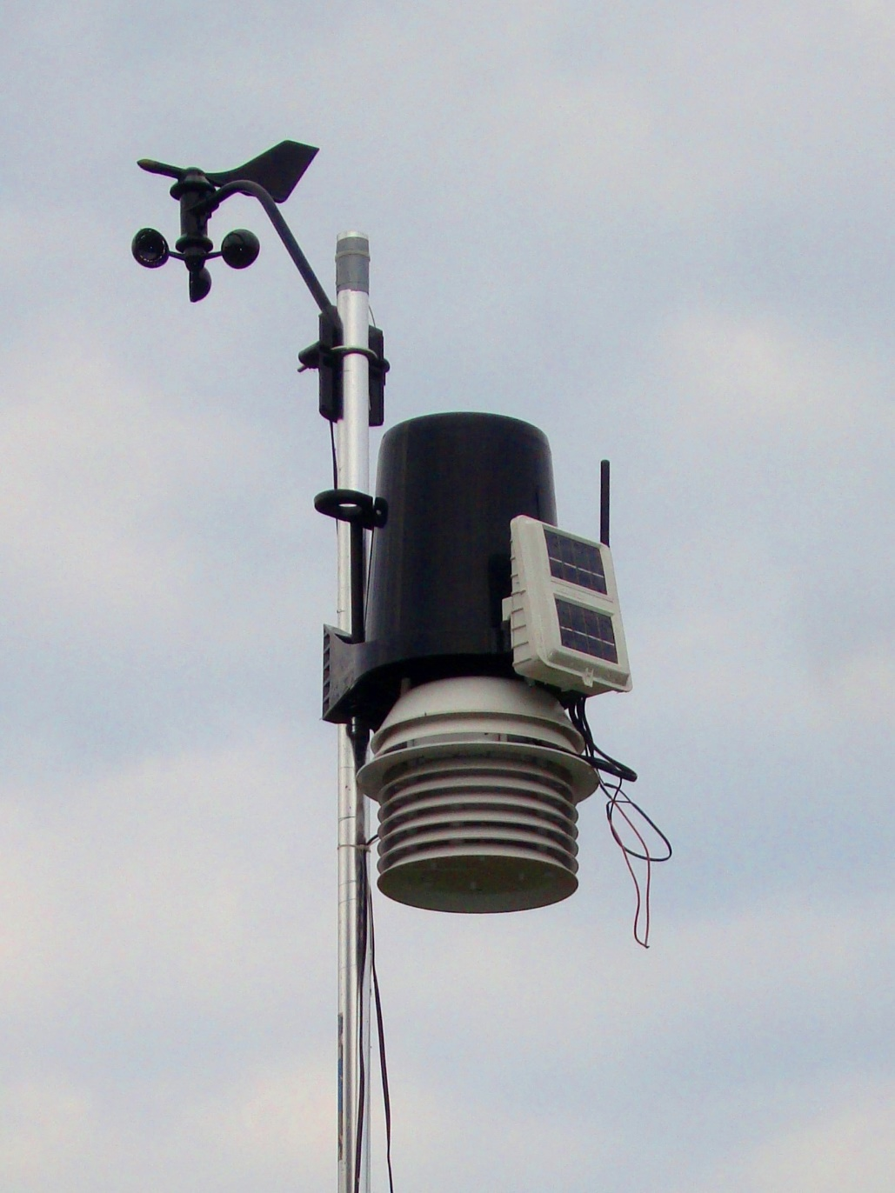

Where to place a weather station
Where would you place a weather station at Reading University and why?
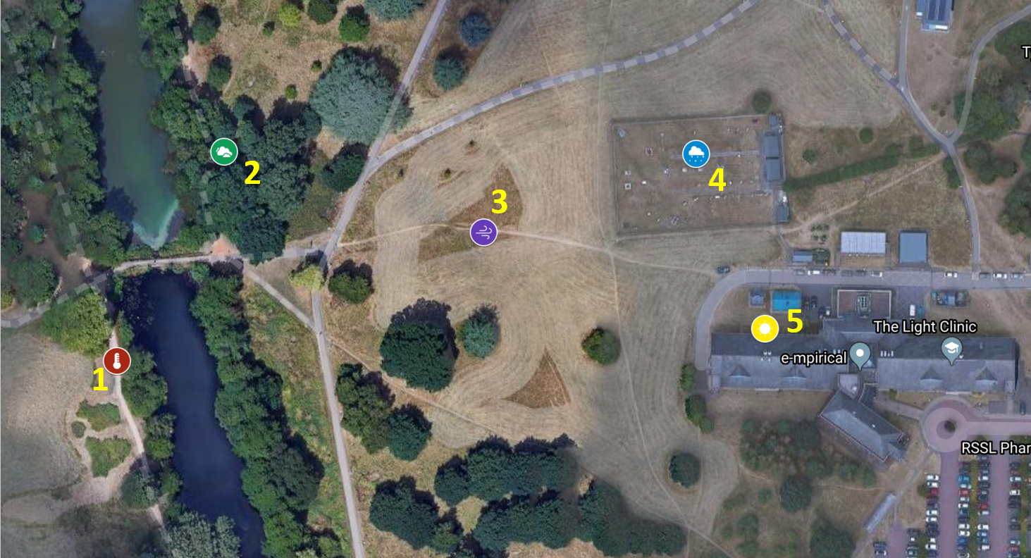
Image source: Google Maps with CNES / Airbus, Getmapping pls, Infoterra Ltd & Bluesky, Landsat / Copernicus, Maxar Technologies

Site | Level ground | No trees that influence measurements | No buildings that influence measurements | In a Frost Hollow? | Close to water source which affects humidity measurement
1
2
3
4
5

I have selected site because

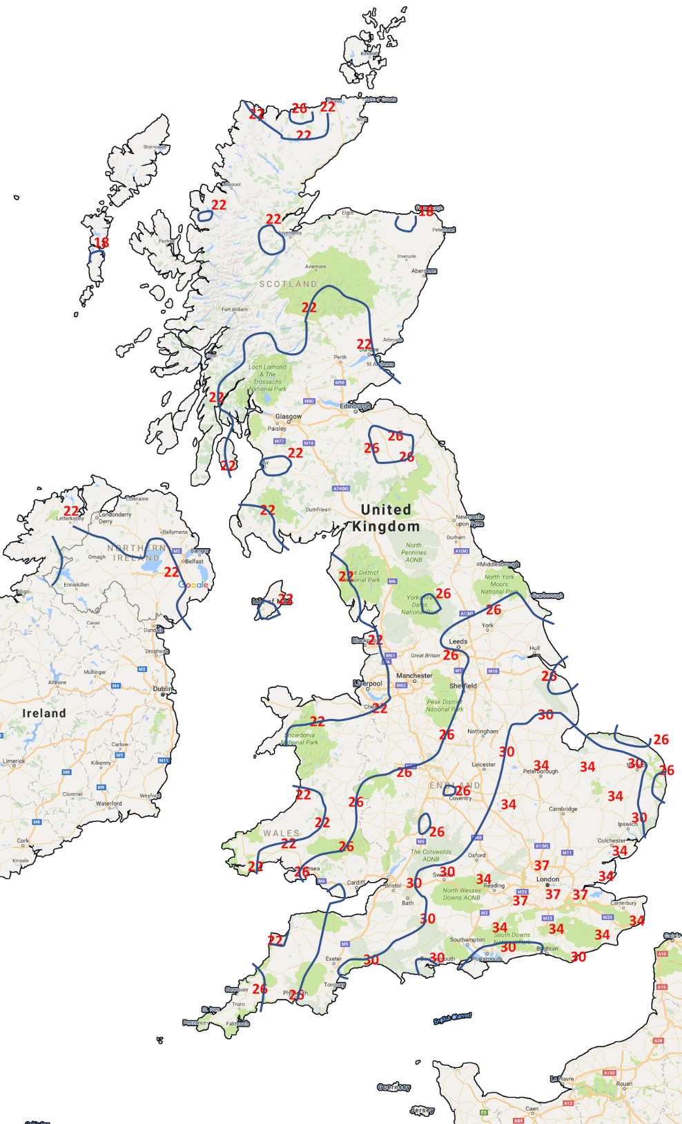
Drawing isotherms
- Complete the map by adding the 34°C and 37°C Isotherms
- Describe your map – what does it show about temperatures in the UK? You can use the sentence starters below and place names to help
My map shows me that…
The hottest temperatures can be found….
As you progress North…
________________________________________________________________________________________________________________________________________________________________________

