URBAN CLIMATES
- Produce definitions of the following words;
- An urban area
- A rural area
- An urban heat island
- How do you think the following characteristics are affected by urban areas;
Weather characteristic | Do you think urban areas have higher or lower than Rural areas?
Sunshine duration
Annual mean temperature
Winter maximum temperatures
Occurrence of frosts
Total precipitation
Number of rain days
Number of days with snow
Cloud cover
Occurrence of fog in winter

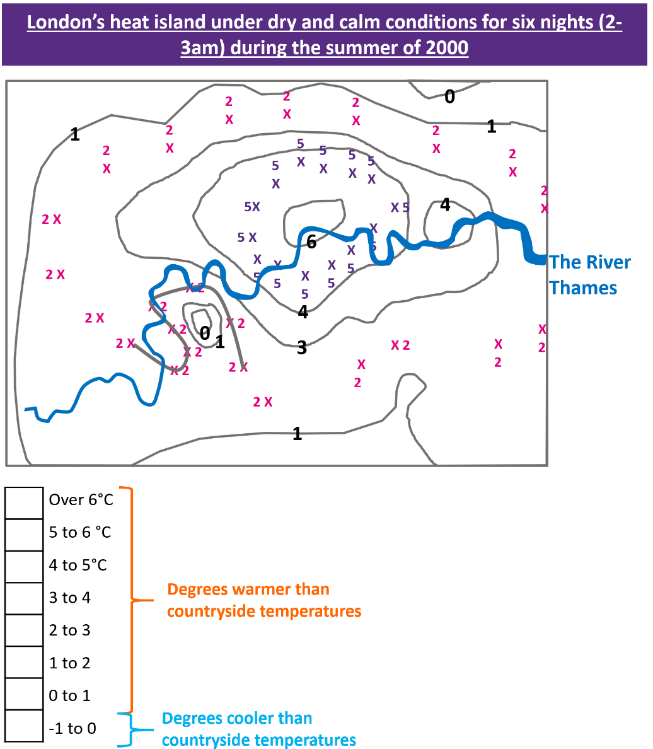
London’s Heat Island
MAPPING TASK
- Complete the line for 2°C using the “x” marks
- Create an isotherm for 5 °C by joining together the corresponding “x” marks
- Shade in the map using the key – think of a colour scale that would work

For your completed map:
- What happens to temperatures with increasing distance from the centre of London?
- Are there any exceptions to this pattern?
- Can you suggest any reasons why this pattern might exist?

- There is little bare earth and vegetation in urban areas , these can cool temperatures.
- In rural areas, there tend to be more lakes, ponds, streams and rivers, these can cool temperatures.
- In towns, when it rains, water tends to be quickly channelled into underground drains and is not left on the surface to cool it down.
- Rural areas have lighter surfaces, so more of the Sun’s energy gets reflected straight back out to space, without heating up the ground (this is known as high albedo).
- Industry, vehicles, heating systems, air conditioning etc. all release extra heat into the urban environment.
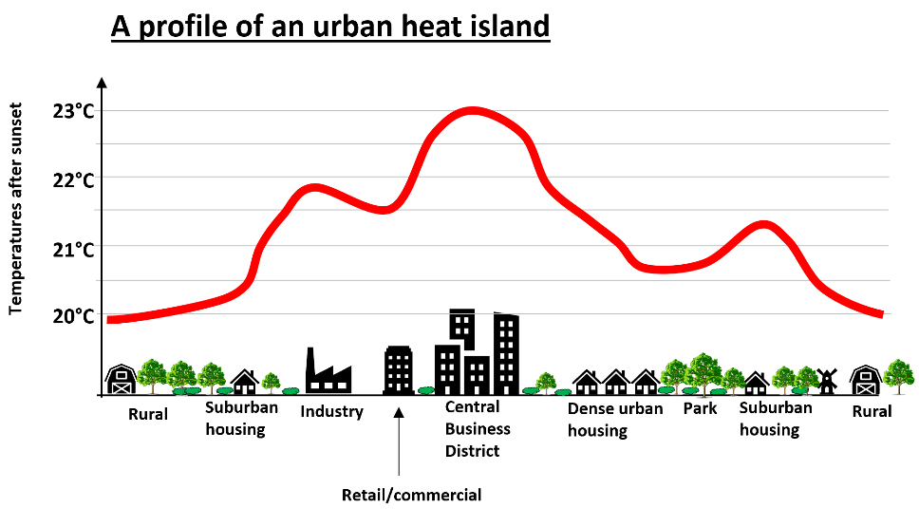
- Describe the urban heat profile on the diagram
- Label your copy of the urban heat profile with the 6 statements opposite – where do they best fit on the diagram?
- Now explain why the Central Business District (CPD) is much hotter than the rural areas
How urban areas affect climate – Winds and precipitation
- Explain what impact cities can have on winds using the diagram below

- Why are cities cloudier and wetter?
- What sources of pollution are there in cities that make it cloudier and wetter?
Urban climates – Strategies to reduce urban impacts on climate
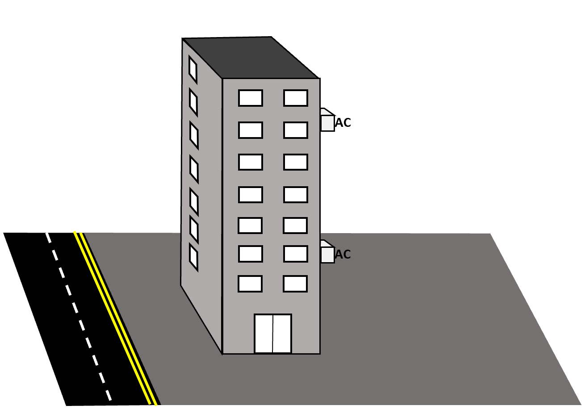

Redesign the building to make it better for urban microclimates. Your goal is to reduce the local temperatures and the impact of the building on urban winds and precipitation. You have £50,000 to do it!
- Choose your solutions! Do not go past £50,000
- Add the solutions to the diagram of the building
- Add a reason for choosing your strategies – how will they help combat urban microclimates?

Cool surfaces – paint the building a lighter colour to reflect light - £15,000 | Insulate the building better with ceiling insulation to stop heat escaping - £5,000
Cool surfaces – paint the pavement a lighter colour to reflect light - £5,000 | Change the windows to triple glazing to stop heat escaping - £15,000
Add a green roof – these reduce temperatures and limit flooding - £10,000 | Plant large trees to provide shade and disrupt impacts on urban winds - £5,000
Add a green wall – these reduce temperatures and limit flooding - £10,000 | Add a pond – these absorb incoming solar energy - £10,000
Remove air conditioning units - £5,000 | Replace pavements/tarmac with grassed areas and shrubs – these absorb energy and store water - £5,000
Insulate the building better with cavity wall insulation to stop heat escaping - £15,000 | Replace pavements with block paving (sustainable urban drainage) to allow water to soak in - £10,000

