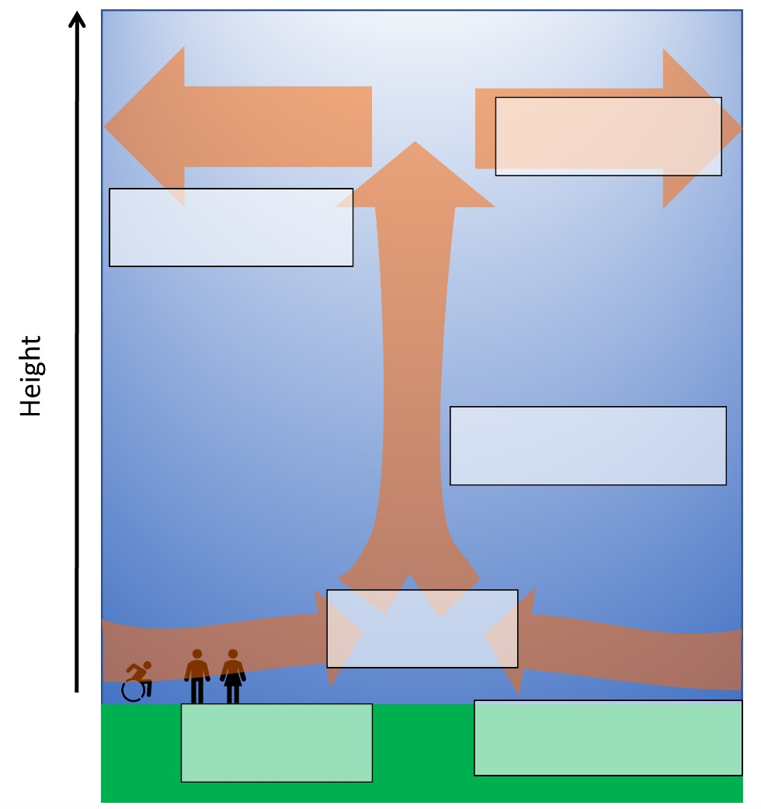
Depressions – a mid latitude low pressure storm system
- Try to organise the information below into a logical order.
- The air flowing in at the ground is slowed down by friction at the Earth’s surface but the air spreading out at the top is not.
- The rising air hits the top of the atmosphere and spreads out.
- This means it’s easier for air to leave the area than to come in.
- Air flows in at the ground to replace the rising air.
- We end up with less air above the Earth’s surface. This is Low pressure.
- First, there are some places in the atmosphere where the air is rising. This can happen if the air is heated at the ground.
- Now add the letter of the information to a logical part of your diagram

Watch the video
- What is a weather front?
- Complete the table below

 | Warm front | Cold front
Situation (complete the sentence) | The warm air is “stronger” than… | If the cold air has the upper hand…
How shown on a weather map (diagram)
What happens at the front
Weather features associated
Pressure is…

The weather in a depression
Complete the table as the video plays.
You will need to work from the Right column to the left!
And ends here!
Video starts here
Work this way!

 | COLD SECTOR  20:00  COMPLETE LAST | COLD FRONT  18:00  COMPLETE FOURTH | WARM SECTOR  16:00  COMPLETE THIRD | WARM FRONT  14:00  COMPLETE SECOND | AHEAD OF WARM FRONT  08:00 - 12:00  COMPLETE FIRST
Air mass
Temperature
Cloud
Precipitation
Wind Speed

Watch the 2 videos
- What weather do depressions like Storm Desmond of 2015 bring to the UK? ____________________________________________________________________________________________________________________________________________________________
- What hazards does this bring with it? ____________________________________________________________________________________________________________________________________________________________

