Depressions skills practice - Homework
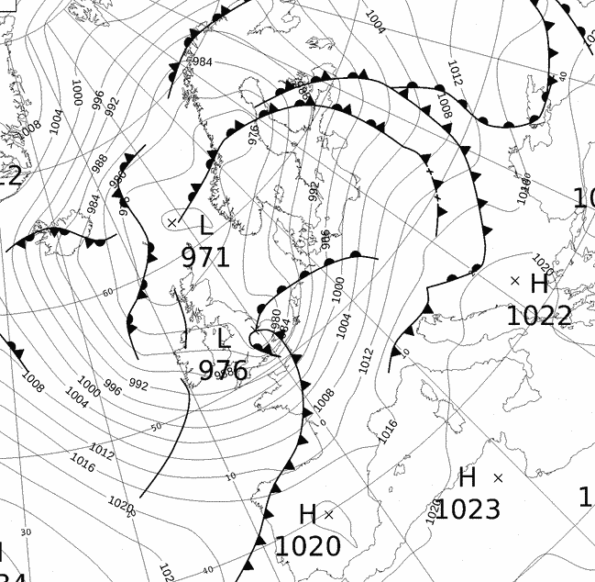
- Add the labels to an appropriate part of the Synoptic chart. Draw arrows from the cloud types to where you might find then on the depression.
Heavy Rain
Low pressure
Anticyclone
High Pressure
Warm Front
Cold Front
Depression
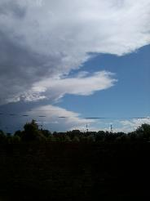
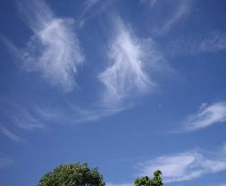
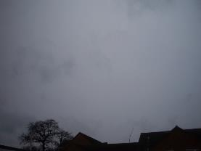

Nimbostratus
Cirrus
Cumulonimbus

Light Rain

- Research one depression that has affected the UK lately. Produce a spider diagram all about it including its name, where it was, when it happened and the disruption it caused.

