Skills practice Homework – A synoptic chart from June 2018
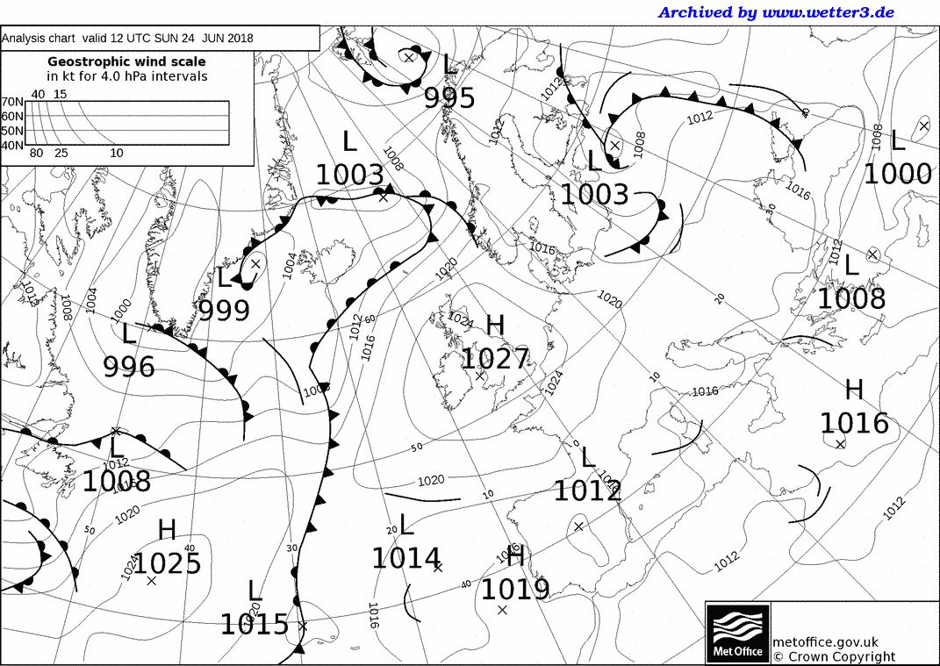

- What is the pressure value over the UK?
- Is this High or Low pressure?
- What can the isobars tell you about wind speeds here?
- What weather system is this?
- Given the date, June the 24th, what weather would the UK be experiencing?

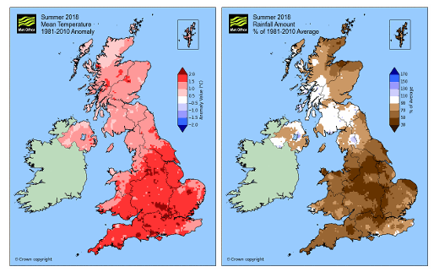

Using the maps above
- Were temperatures higher or lower than the mean temperature?
- Which locations in the UK had the highest temperatures?
- What happened to the temperature anomaly as you go North through the UK?
- What did the anticyclone do to rainfall amounts?
- Which parts of the UK were most affected by a lack of rainfall?
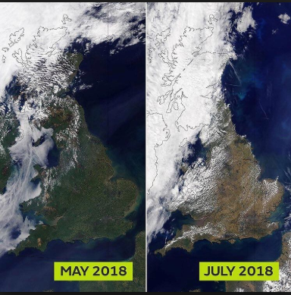
- Look at the satellite images, what has happened to the colour of the vegetation? Why do you think this is the case?
All images © Crown copyright, Met Office

