Anticyclones
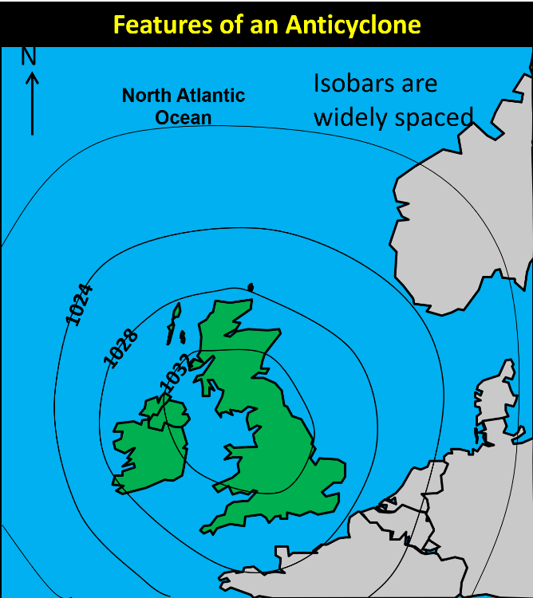
- Define the term anticyclone based on the passage

- Use the diagram opposite to describe the characteristics of an anticyclone. Mention isobars, wind direction and size in your answer
- What weather conditions would anticyclones bring to the UK:
- In summer
- In winter
Use the information below and pop them into the Venn diagram
Very cold nights
Dry
Clear skies
Snow
Morning Frost
Light winds
Fog
Dry
Sunny days
Very hot days

Summer
Winter

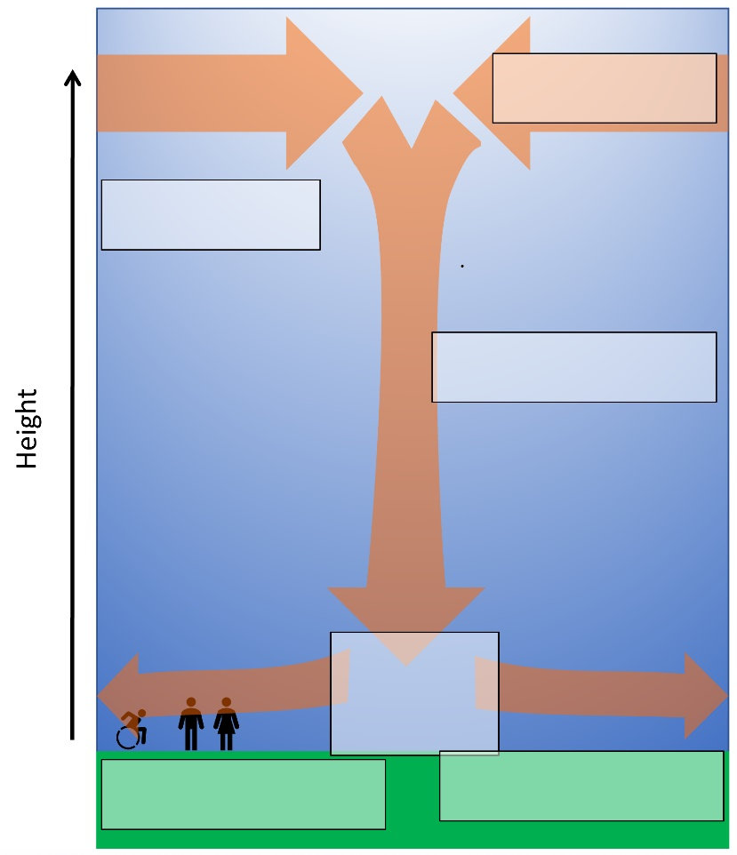
- Try to organise the information below into a logical order.
- Now add the information to a logical part of your diagram
Sequence position?
- The air spreading out at the ground is slowed down by friction at the Earth’s surface
- We end up with more air at the ground. This is the high pressure we get in an anticyclone
- There are some places in the atmosphere where the air is sinking
- The air flowing in at the top is not slowed by friction. This means it’s easier for air to come into the area than to leave it.
- The sinking air hits the ground and spreads out.
- Air flows in at the top to replace the sinking air.

Case studies of summer and winter anticyclones
 | Positive effects on people | Negative effects on people
Summer 2013
Winter 1963

