The Climate Crisis
- Watch the video - Do we need to act on Global Warming? Is Greta correct? What arguments does she make? Write down a quote that catches your imagination.
- Match the quote with the people – do it in pencil!
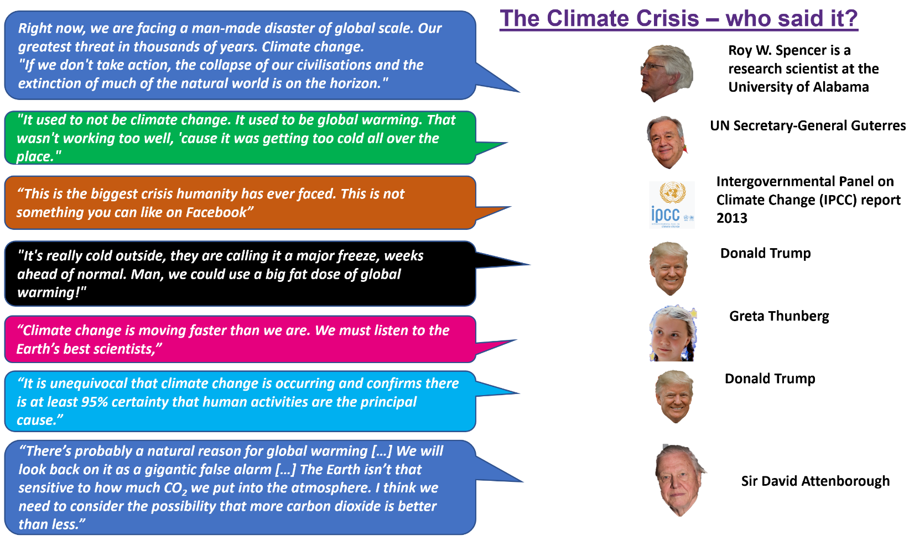

Use the website below to complete your table DESCRIBING what would happen to the places with different amounts of sea level rise. It may be worth naming places affected and what % of the place could be affected http://www.floodmap.net/

Place | 1m sea level rise | 6m sea level rise  (if Greenland melts) | 60m sea level rise  (if Antarctica melts)
Where I live
The UK
The Netherlands
Bangladesh

Sea Level Change
Using the graphic below
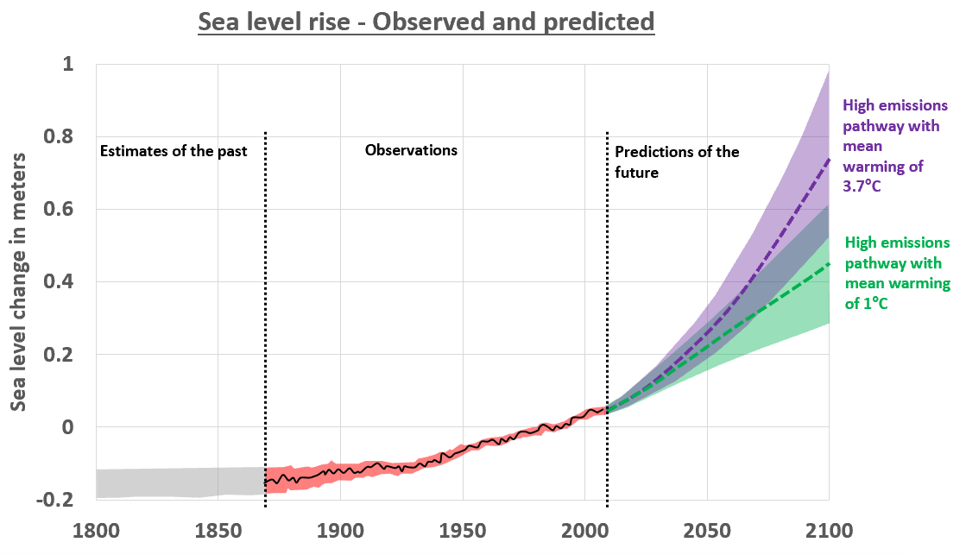
- How much sea level change have we actually observed?
- How much sea level rise could we see by 2100?
- According to the BBC, up to 630 million people live today on land that is projected to have annual flood events by 2100. 250 million live less than 1m above the current high tide line. Does this present a climate crisis? ________________________________________________________________________

The Climate Crisis - Tipping Points and feedback loops

TASK – add the statements below to the correct part of the feedback loop

- This makes the ocean’s surface less reflective so more of the Sun’s light is absorbed rather than reflected.
- This increases the warming in these regions

- Sea-ice melts which exposes a much darker ocean.

- Global warming heats the atmosphere and oceans.

The Climate Crisis – GIS exercise
Complete the table below using the Hyperlinks
 | Who Pollutes?  http://www.globalcarbonatlas.org/en/CO2-emissions | Who Strikes? https://fridaysforfuture.org/action-map/map/  (Just give an estimate of number of strikes) | Gains or loses?  https://web.stanford.edu/~mburke/climate/map.php
UK
USA
India
DRC

What does your table reveal about the links between who pollutes, who strikes and who gains/loses?

