Changing UK Climate – what will our climate look like in the future?

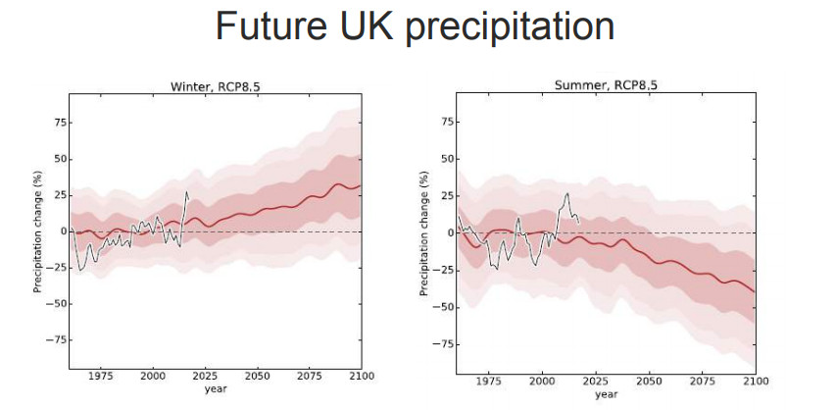
- Using the graph opposite;
- What is predicted to happen to precipitation in the UK in the winter?
- What hazards could this bring in Winter?
- What is predicted to happen to precipitation in the UK in the Summer?
- What hazards could this bring in Summer?
As we don’t know how much greenhouse gas will be emitted in the future, projections of future climate change are based on ‘scenarios’. A HIGH emissions scenario might involve the world emitting similar amounts of greenhouse gases to today’s emissions. A LOW emissions scenario could be achieved if countries work together to drastically reduce the amount of greenhouse gas being added to the atmosphere.
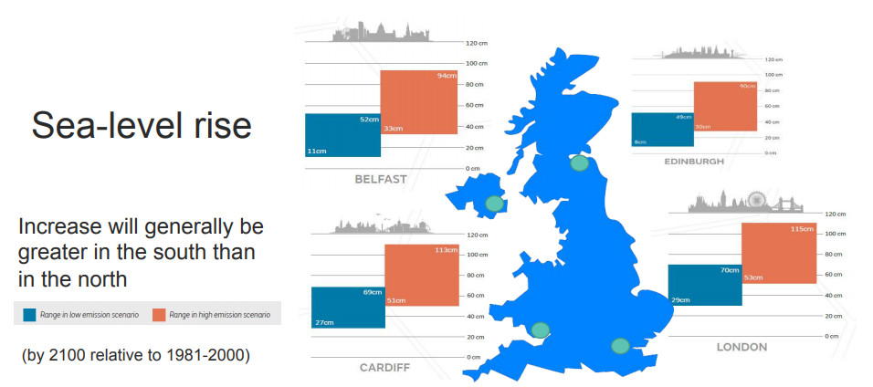
- Using the graphic above;
- Which city will suffer the greatest sea level rise?
- What is the smallest sea level rise indicated on the graphic and where is it?
- Why is it important to keep emissions in the “low emission scenario”?
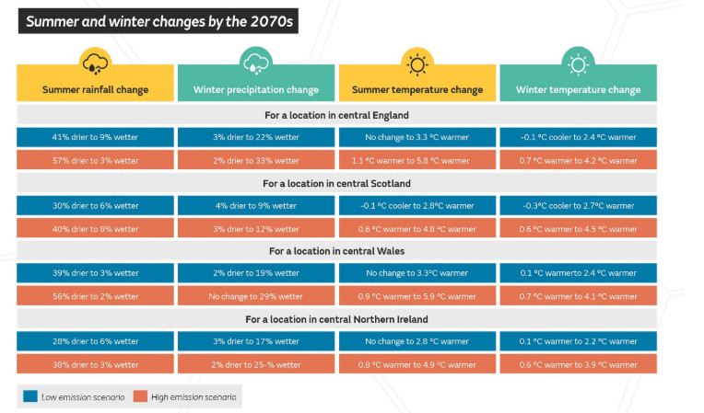

- Select the area closest to where you live from the table above. For the High Emission scenario describe what your climate could be like in 2070.

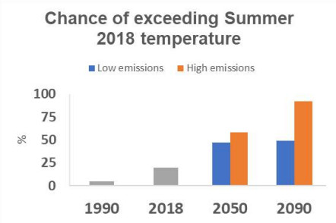
- Using the graphic opposite explain what is expected to happen to summer temperatures in the UK in the future compared to summer 2018.

