Changing UK Climate
Changing temperature in the UK
 | 1901-1930 temperature averages | 1981-2010 temperature averages
JAN | 4.2 | 4.4
FEB | 4.2 | 4.4
MAR | 5.5 | 6.6
APR | 7.6 | 8.5
MAY | 11.3 | 11.7
JUN | 13.8 | 14.5
JUL | 15.8 | 16.7
AUG | 15.2 | 16.4
SEP | 13.1 | 14.0
OCT | 9.8 | 10.7
NOV | 5.8 | 7.1
DEC | 4.5 | 4.6
Mean
Range

- Calculate the Mean for both time periods
- Calculate the Range for both time periods
- What has happened to temperature over time?
- Is this pattern the same for all months?
- Overall what does this show us about the climate in the UK?

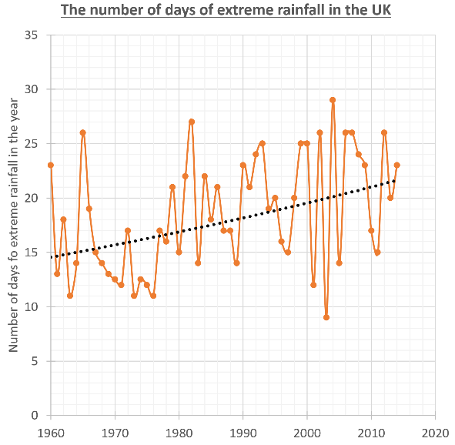
What does this graph show:
- About the extreme rainfall from 1960 to 2014?
- How could this impact upon people?

Complete the summary table
What happens over time?
Average temperatures
Number of extreme rainfall days

What impacts could a changing climate have on the UK in the FUTURE?

- In cities heatwave temperatures will become a normal summer by 2040 | - There could be a move to electric vehicles which will also reduce urban air pollution | - Coastal regions will experience more tidal flooding and coastal erosion | - UK sea waters will become warmer and this will affect fish stocks
- Hospitals, care homes ad schools are not being adapted for warmer weather | - More variation in rainfall could lead to water shortages | - The area of urban greenspaces in the UK is no longer falling and could even increase | - There is evidence that plankton (the base of ocean food chains) is becoming less abundant in UK waters
- 11,000 homes were protected against coastal erosion between 2010 and 2015 | - Climate change will increase the frequency and intensity of floods, with 4 million homes in England already at risk | - Sewerage networks lack the capacity for heavier rainfall | - Fewer people will die from cold related deaths and fuel poverty
- £15 million has been given for natural flood management projects | - Extreme rainfall will bring more flooding to our rivers | - Habitats and natural flood protection will be lost to sea level rise | - There are opportunities to use more sustainable energy such as solar and wind. These could provide local energy rather than imports of fossil fuels.
- More coastal storms threaten coastal infrastructure such as power stations and ports | - There could be more water bourn pathogens, pests and diseases | - Coastal areas will see an increase in tourism and leisure visitors | - New species will colonise our seas and our land
- Some crops will see an increase in productivity | - Moving away from coal and oil to wind and solar energy also improves air quality. | - There will be more heat related health impacts for people | - There will be more wildfire risks to farming and forestry

Classify the slips in the table as either OPPORTUNITIES or RISKS – use colours or the letters O and R

Overall does it look as though the UK is ready for the risks and opportunities faced by climate change?

