Climate in the UK
- Visit https://www.metoffice.gov.uk/research/climate/maps-and-data/uk-climate-averages
- Complete the table below for your most LOCAL weather station

Month | Maximum temperature (°C) | Minimum temperature (°C) | Days of air frost (days) | Sunshine (hours) | Rainfall (mm) | Days of rainfall ≥1 mm (days)
My local Weather station name:

UK Annual Total or average | 12.4 | 5.3 | 54.6 | 1372.8 | 1154 | 156.2

- How does your data compare to the UK average? You should discuss each element of data in the table
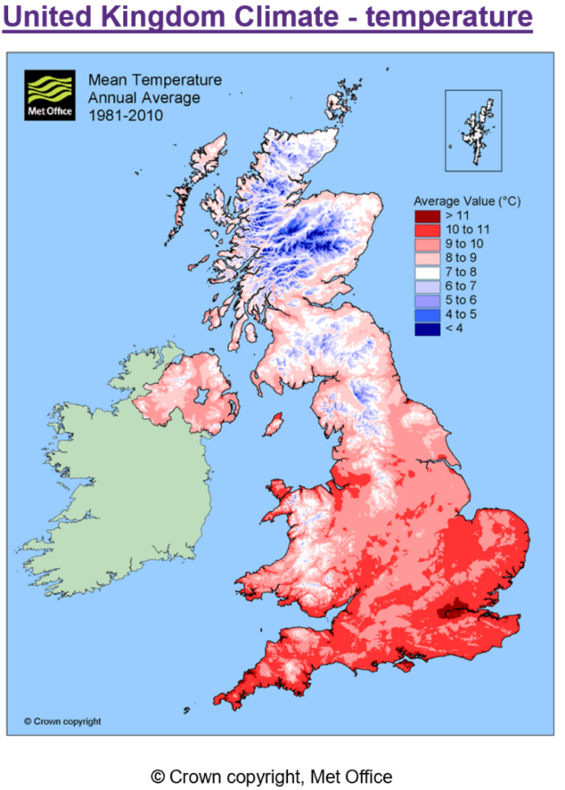
- What do the colours on the map show?
- What range of temperatures does the UK have?
- What generally happens to temperature across the UK? Try to describe the pattern
- Why do some areas of the UK have a colder climate than others?

UK Climate Zones
- Using the maps of climate features of the UK complete all of the tables for all 4 zones. Take the dominant (the one that appears the most) colour in the zone for your value
- Which zone do you live in? Draw a dot to represent you on the map!

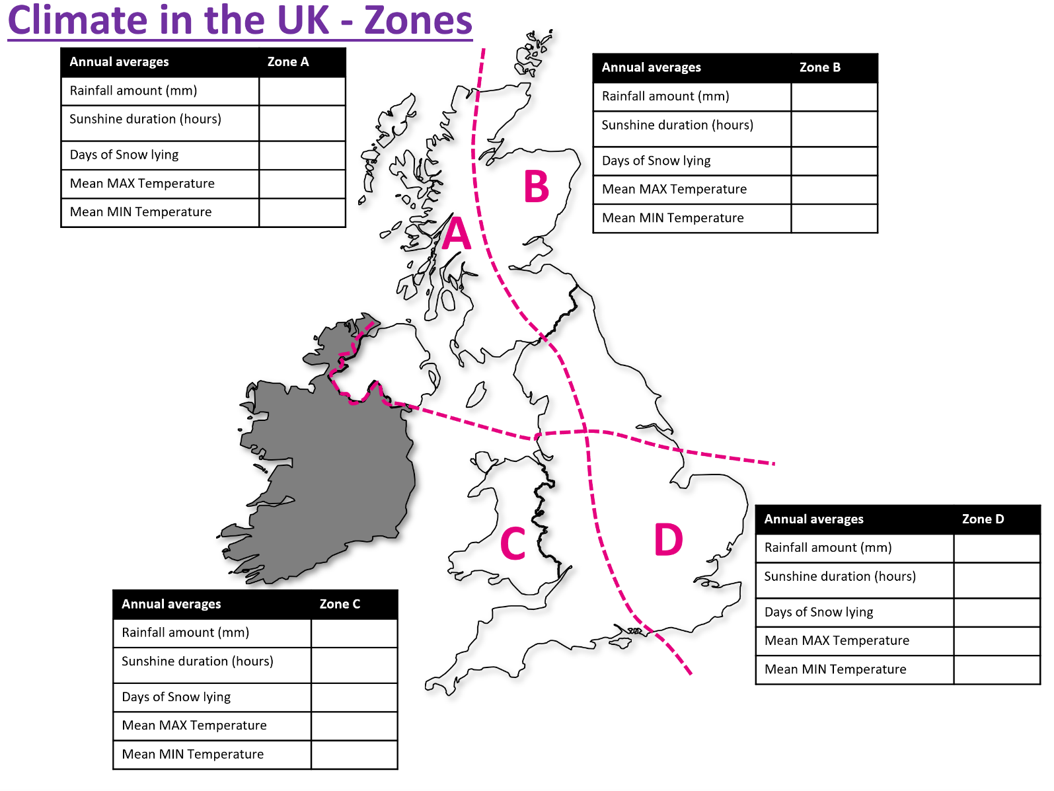
- Which zone do the following descriptors go with?

Descriptor | Zone
Cold winters, cool summers, lower rainfall
Cold winters, warm summers, lower rainfall
Mild winters, cool summers, heavy rainfall
Mild winters, warm summers, heavier rainfall

- Add them to your map
- In which zone would you like to live? Justify your answer

Why does the UK climate vary?
Read carefully the text on local climate variations in the UK
- Explain how the prevailing wind affects precipitation levels in the UK

- Which factors affect the temperature across the UK? Make a list.

- Why does it generally get cooler as we move North through the UK?

- Which factors most affect where you live?

