UK Climates Homework
Graph Number

Reason

Graph Number

Reason

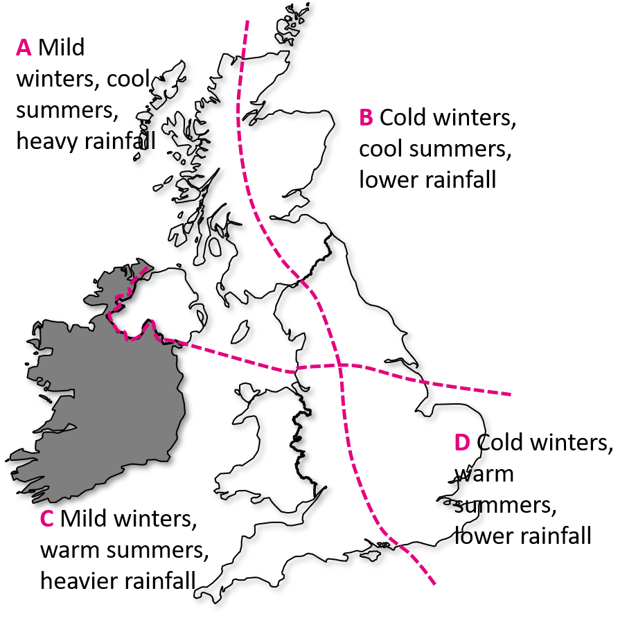
Graph Number

Reason

Graph Number

Reason

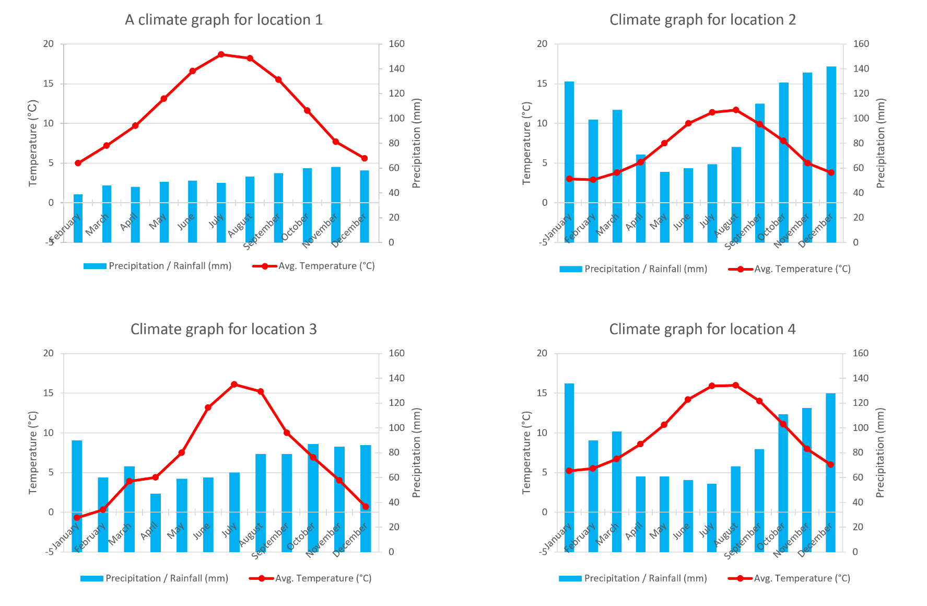
Study carefully the graphs below. Which location could be found in each climate zone? Write the location number in the boxes above.
- Which location is the warmest?
- Which is the only location where the temperature drops below freezing on average in a given month?
- Which location is the wettest?
- Which location is the driest?
- In which location would you prefer to live and why?

