UK Climate - Local Climate Variations
Regionally, UK climate varies because of:

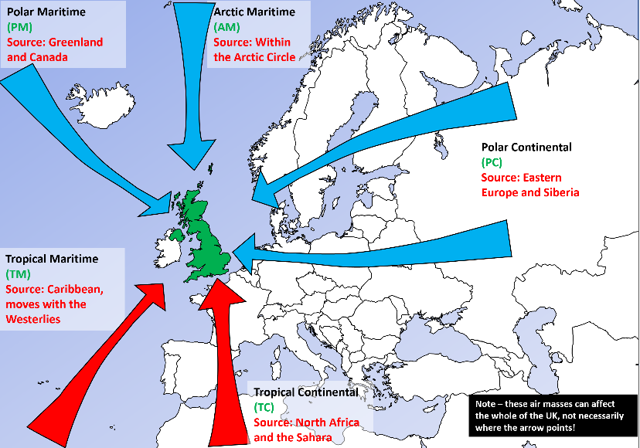
- Prevailing wind direction
The prevailing wind direction is one of the most important factors controlling local climate variations around the British Isles.
Considering Air Masses, the prevailing wind direction will largely determine the temperature, humidity and rainfall. The weather associated with the wind direction will vary around the Islands.

For example, a polar maritime air mass (north westerly to west south westerly wind) will bring rainfall primarily to western areas of the UK, and this is our prevailing wind direction. A polar continental air mass will bring rain (or snow) primarily to eastern areas.

The wind direction will also affect things like the extra rainfall on the upwind side of hills (relief rainfall), the area in the rain shadow of any mountains and the Föhn effect.
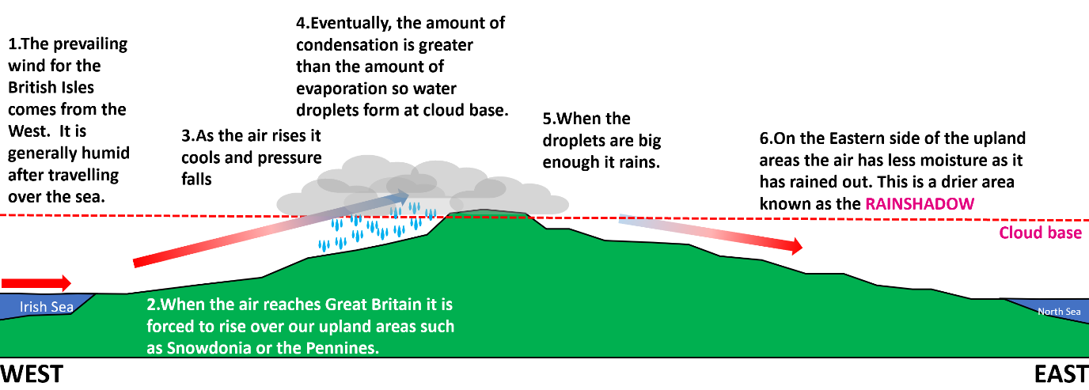
- Altitude
As we go up through the atmosphere (change altitude) air pressure falls and so temperature falls.
This is because as the pressure falls, the air expands, pushing out against the surrounding air. As the air does work pushing the surrounding air aside, it loses energy and so cools. So, as air rises the pressure falls and it cools. This means mountain areas are colder than those lower down. This also means clouds may form which may in turn lead to precipitation.

- Distance from the sea

Water has a higher heat capacity than air, meaning that it warms and cools more slowly. In the winter, the warmer water will prevent local air temperatures from falling too much. In the summer, the cooler water will prevent local air temperatures from rising too much. The closer you are to a large body of water, the smaller the seasonal variations in temperature.

In addition, the North Atlantic Drift, part of the Ocean Circulation, brings warmer surface waters to the UK. These in turn raise the temperature of the prevailing westerly winds, raising the temperature locally by up to around 5°C in winter.

- Latitude
Temperature falls with distance from the tropical regions. This is explained in the diagrams below. In the graph, the blue line shows the energy the Earth receives from the Sun. The UK lies between about 50°N and 65°N- between these latitudes, the amount of sunshine the Earth receives falls fast.
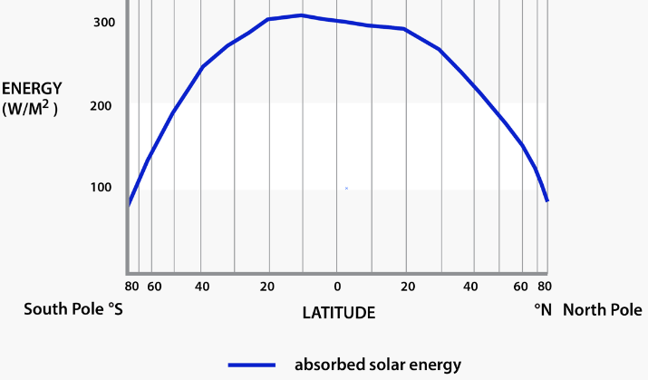
- Urban effects

Urban areas have an impact on their climate because of the processes going on there, their structure and the materials they are made of. They can make the temperature higher, winds more turbulent and increase precipitation.

