Past Climate Change
RECENT CHANGE

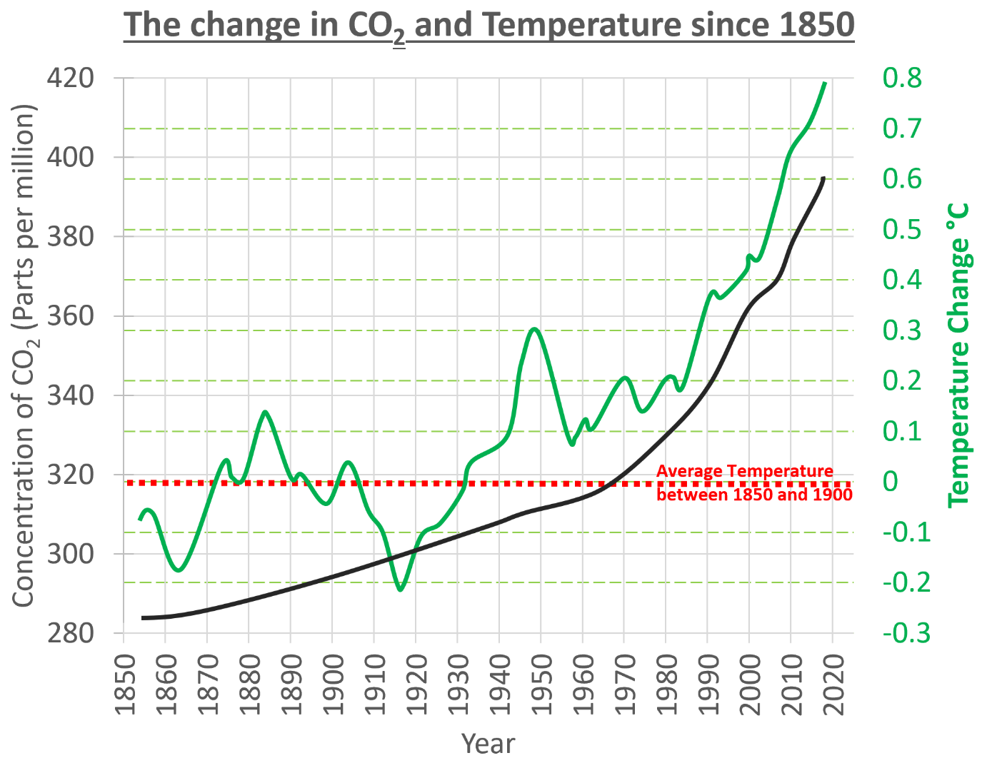
Describe the patterns on this graph.
- What happens to the temperature over time? What are the start and end values for temperature?
- What happens to the CO₂ over time? What are the start and end values for CO₂?

CAUSES OF THE CHANGE
Using video 1 https://youtu.be/lrPS2HiYVp8 :
- What drives the Earth’s climate system?
- What happens to the Sun’s energy when it reaches our atmosphere?
- What happens to the Earth’s heat?
- Without the Greenhouse gases would we be able to live on Earth?
Draw a diagram to show how the greenhouse effect works
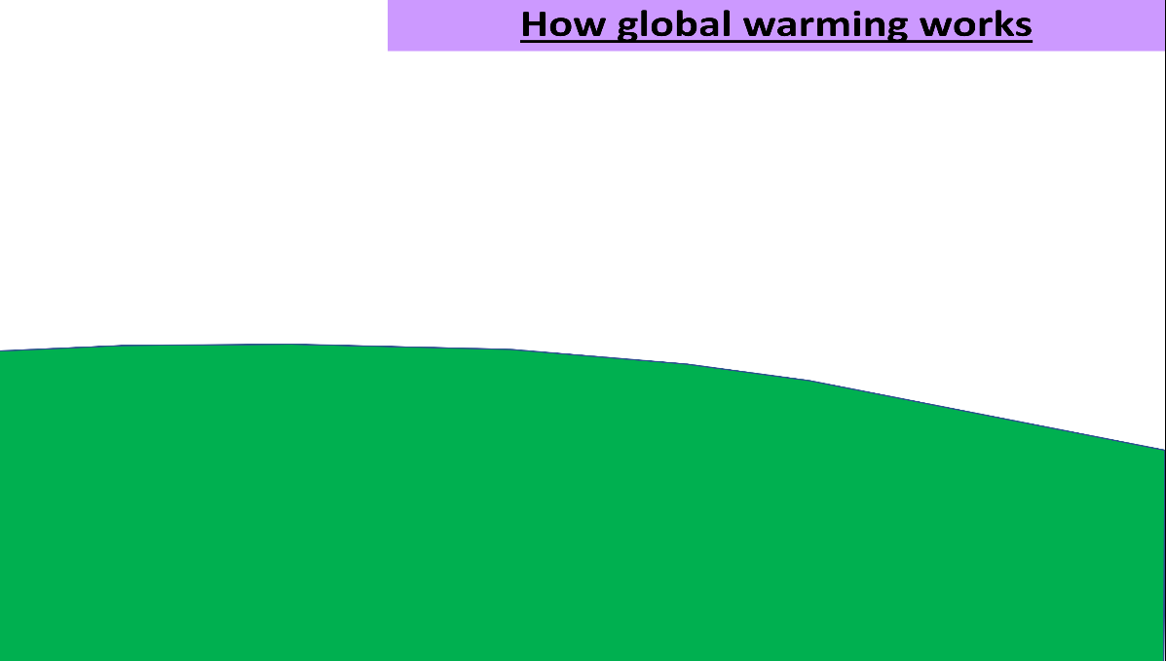
Using video 2 https://youtu.be/uHbxSYDqTR8 ;
- What has happened to temperature over the course of the last century?
- What has been the average global temperature?
- What does the evidence point to?
- What natural events can cause warming of our planet?
- What does most evidence suggest about the recent warming we have seen on planet Earth?
- Which activities increase the concentrations of greenhouse gases in the atmosphere?
- What sources of CO₂ are there?
- What sinks of CO₂ are there?

