Global Climate Change – Homework activity

The emissions shows how much carbon is being put into the atmosphere
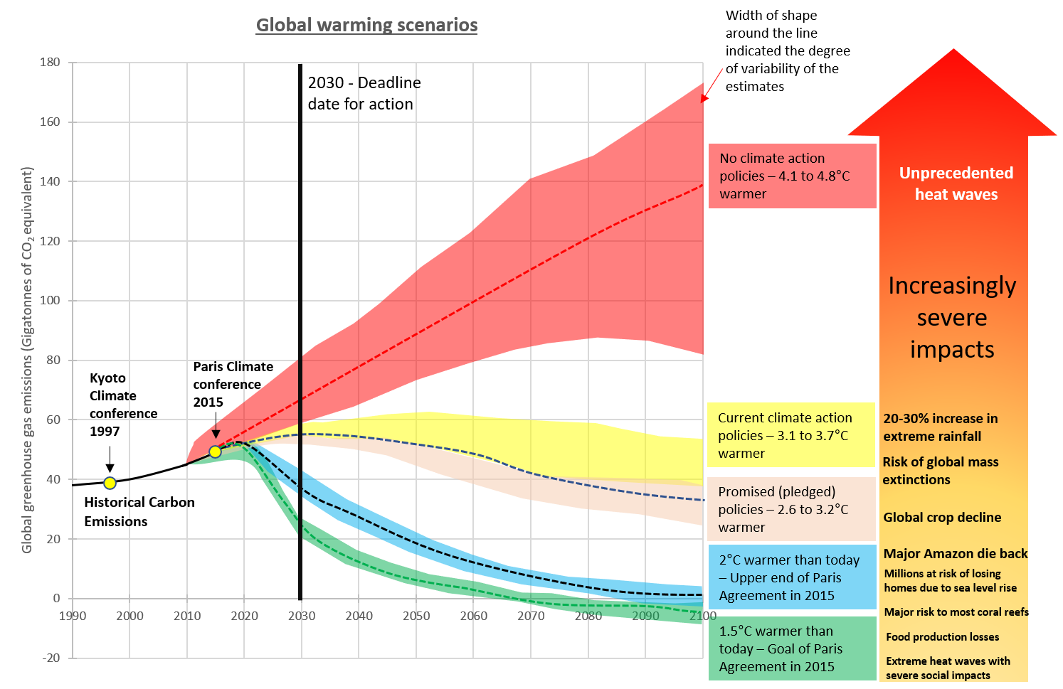

ACTIVITY –
The Paris Climate Agreement of 2015 set a deadline of 2030 to CUT our greenhouse gas emissions (the gases we put into the atmosphere polluting it). Study carefully this graphic on current and future greenhouse gas emissions and the potential temperature change that could result.

The temperature impacts –
Answer the following questions using the graph;
- If there are no climate action policies how much warmer will our planet be in 2100?
- If we stick with “current climate action policies” how much warmer will our planet be?
- If we meet the goals of the Paris agreement what will happen to the temperature?
Impacts on people and the environment
The impacts arrow on the right of the diagram matches the climate action policies.
- What possible impacts of climate change are there if the world follows “promised (pledged) policies”?
- Even if we meet the goals of the Paris Agreement what impacts are there?
The Future
- Consider these Geographical Futures, take some notes about;
- Probable futures – of the 4 lines on the graph what do you think is most likely to happen?
- Preferable futures – what would you prefer to happen out of the 4 lines? Why?

