Hot Deserts- Climate

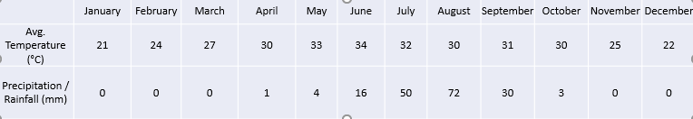

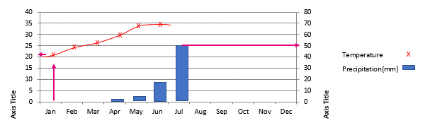
- Plot the climate data for Timbuktu
- Add up the total precipitation ________________
- Does Timbuktu have less than 250mm (the classification of a desert)?_________________
- Which climate zone is it in?______________________

