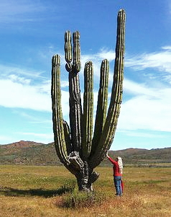
How plants and animals adapt to the physical conditions of a hot desert
The extreme nature of desert environments means that plants and animals must adapt to survive. Plants and animals are regularly exposed to extreme temperatures and drought conditions. They must also cope with extensive water loss.
Desert Plant Adaptations
- No leaves or small seasonal leaves that only grow after it rains - this helps reduce water loss during photosynthesis. These plants conduct photosynthesis in their green stems.
- Plants can store water in their stems or leaves, these are called succulents;
- Many plants have long root systems spread out wide or go deep into the ground to absorb water;
- Short life cycles - some plants germinate in response to rain, grow, flower, and die within one year. These plants can therefore avoid drought.
- Leaves with hair - these help shade the plant, reducing water loss. Other plants have leaves that turn throughout the day to expose a minimum surface area to the heat.
Desert Cactus by Imartin6 (Own work) [CC BY 3.0 (http://creativecommons.org/licenses/by/3.0)], via Wikimedia Commons
- Spines to discourage animals from eating plants for water;
- Waxy coating on stems and leaves - this helps to reduce water loss.
- Many plants are slower growing – this requires less energy. The plants don't have to make as much food and therefore do not lose as much water.
The cactus shown is well adapted for survival in the desert. They have many of the features listed above.
Desert animal adaptations
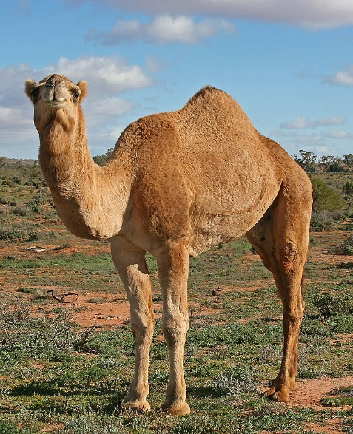
Animals also have to cope in the desert, using adaptations such as being nocturnal or living under ground to survive. Camels often live in deserts that are hot and dry during the day, coping with wind-blown sand and cold at night. They are well adapted for survival in the desert. Camels have:
- Thick fur on the top of the body for shade, and thin fur elsewhere to allow easy heat loss.
- Large surface area to volume ratio which maximises heat loss.
- Large, flat feet to spread their weight on the sand.
- The ability to go for a long time without water - they lose very little through urination and sweating.
- A fatty hump which provides energy in times of food shortages (they don't store water in their humps).
- The ability to tolerate body temperatures up to 42°C.

Jjron / CC BY-SA

