Hot Deserts

Read the text on camel and cacti adaptations
Annotate your pictures of the camel and cactus to show how they have adapted to the desert environment

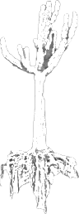

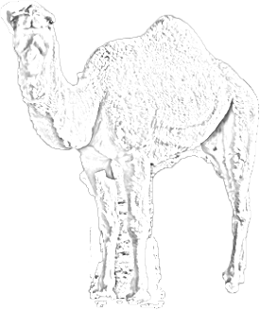

Making plants and animals – Hot deserts

TASK:
You have to create both a plant and an animal using the characteristics on the tables provided. Both of these need to fit the climate and environment of a hot desert.
- Your plant and animal can have 6 characteristics each
- List the characteristics that would be useful
- Pick six from the lists below
- Creatively draw both your animal and plant to display its adaptations to the climate of hot deserts.
- Name your plant or animal
- Around your drawing you need to JUSTIFY the characteristics, linking to the original data sheet. This should be written in full and link to the actual climate.

PLANT CHARACTERISTICS

Drought resistant | Loves water | Stores water
Wide root system | Deep root system | Lives on other plants
Floats | Survives under water | Dies back seasonally
Waxy, pointed leaves | Deciduous | Evergreen
Broadleaves | Needle leaves | Stunted
Thick bark | Rough bark | Wind blown seeds
Heavy-weighted seeds | Fragments take root | Seeds with Velcro like hooks
Runners put down roots | Climber | Like strong sun
Likes shade | Tall | Salt tolerant
Bears fruit (nuts and berries) | Flowering | Pollinating
Eats insects | Branching | Sticks to rocks
Lifecycle within days | Colourful | Drab
Pleasant smell | Awful smell | Changes colour
Buttress roots (large roots to support huge trees) | Flexible branches | Sticky surfaces
MAKE UP YOUR OWN CHARACTERISTICS AS WELL!

ANIMAL CHARACTERISTICS

fast runner | Can get fat | Powerful digging claws
Migratory | Thick skin | Spotted fur
Can stand on 2 legs | Large ears | Long neck
Striped fur | Sharp claws | Grinding teeth
Sharp incisor teeth | Swims | Thick fur
Climbs trees | Thick pads on paws | Nocturnal
Good eyesight | Webbed feet | Can hibernate
Can close nostrils | Agile | Slippery skinned
Good sense of smell | Gives off bad smell | Stores water in body
Strong skeleton | Loud voice | Gregarious (lives in groups)
Stamina | Brown fur | Prehensile (gripping) tail
Large body | Very thin body | Whiskers
Can hold breath for 1/2 an hour | sociable | Fierce growl
MAKE UP YOUR OWN CHARACTERISTICS AS WELL!

