Hot deserts – GIS homework task
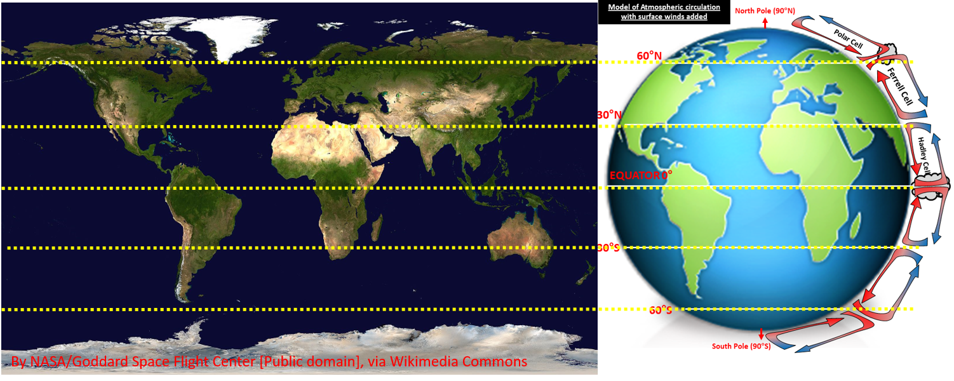
- Look at the satellite image of the world above from NASA via Wikimedia Commons.
- What is the vegetation cover like at 30°N and S of the Equator?
- Using the model can you suggest why that is?

- Visit Nasa maps at https://earthobservatory.nasa.gov/global-maps/MOD_NDVI_M and complete the table below.

Focus on the Southern edge of the Sahara shown on the next map (the Northern Part of sub Saharan Africa)

Map to Play | March 2000 | August 2000 | November 2000
Vegetation (does it grow or recede?)
Temperature (does it get hotter or cooler?)
Rainfall – does it get wetter or drier?

- Overall, can you spot any links between temperature, precipitation and vegetation growth?
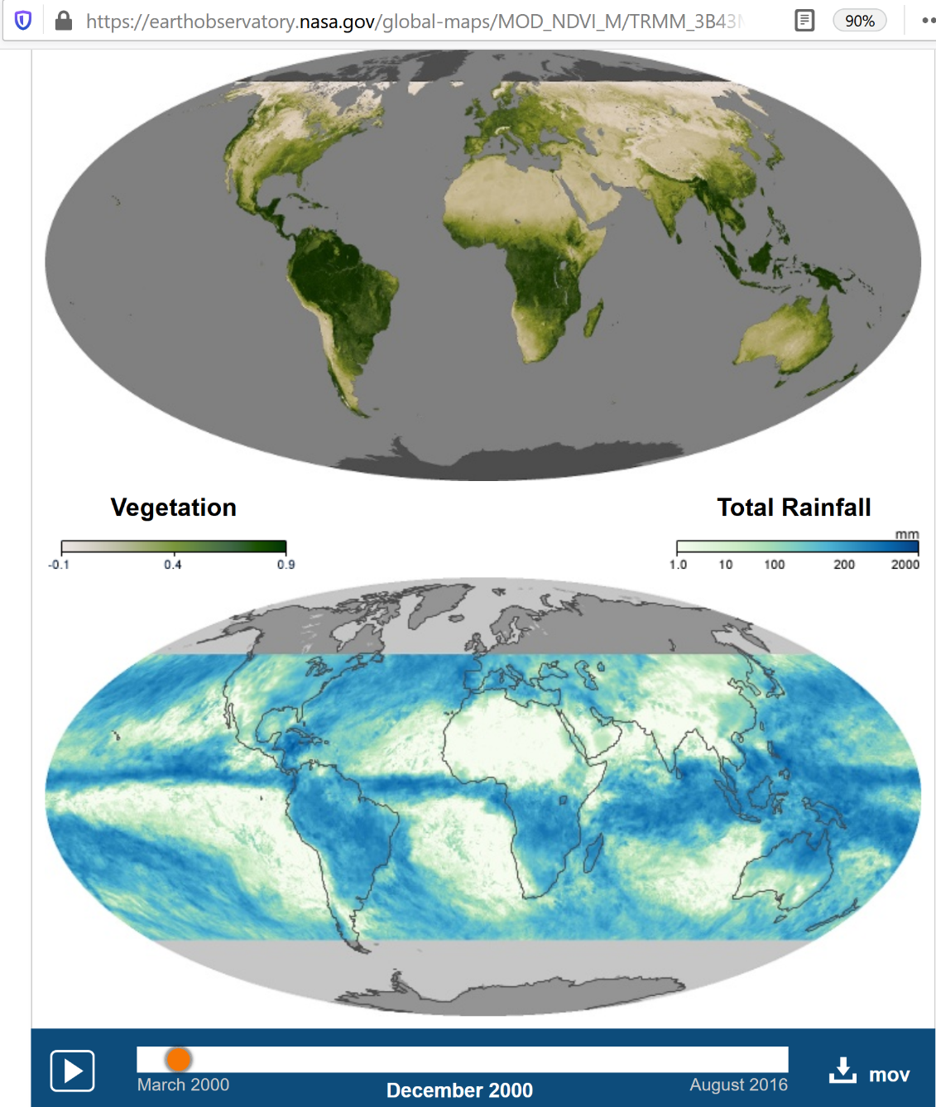
Date the satellite image was taken
Area to focus upon in Africa
WARNING – the GIS map can flicker when played. Anyone with medical conditions provoked by flickering images should not watch this animation
Press play and Pause using this button to freeze the maps at the times indicated in the table

