Polar climates
So it is more concentrated
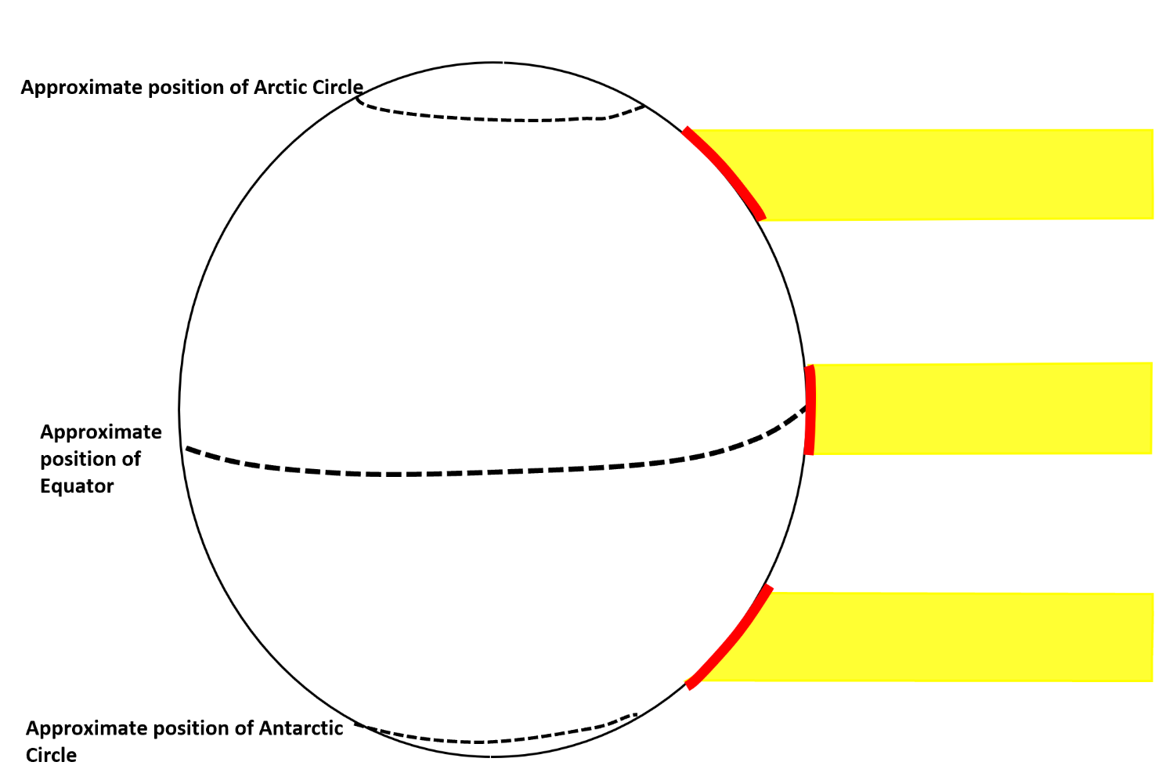
The Sun’s energy hits the Equatorial regions flat on
So it is less concentrated
Further North and South the curve of the Earth means that the same amount of solar radiation has more land to cover

- Add the labels opposite to an appropriate point on your diagram above
- In a paragraph explain why it generally gets colder as we move from the equator to the poles
- Based on this information – where would YOU like to live and why?

TEMPERATURE DATA (°C) FOR 2 RESEARCH STATIONS IN ANTARCTICA
 | Jan | Feb | Mar | Apr | May | Jun | Jul | Aug | Sep | Oct | Nov | Dec | Mean Annual temperature
1 Vostok | -32 | -44 | -58 | -65 | -66 | -65 | -67 | -68 | -66 | -57 | -43 | -32
2 McMurdo | 0 | -6 | -14 | -17 | -19 | -19 | -22 | -23 | -21 | -16 | -7 | -1

PRECIPITATION DATA (mm) FOR 2 RESEARCH STATIONS IN ANTARCTICA
 | Jan | Feb | Mar | Apr | May | Jun | Jul | Aug | Sep | Oct | Nov | Dec | Total
1 Vostok | 0.1 | 0 | 0.7 | 0.5 | 0.4 | 0.5 | 0.6 | 0.7 | 0.3 | 0.2 | 0.1 | 0
2 McMurdo | 15 | 21.2 | 24.1 | 18.4 | 23.7 | 24.9 | 15.6 | 11.3 | 11.8 | 9.7 | 9.5 | 15.7

- Calculate the mean annual temperature and the total precipitation for both stations.
- Look at the temperature data – can you explain why it is so cold at both stations referring back to what we have just learnt? ___________________________________________________________________________________________________________________
- Is there a lot of precipitation or a small amount?
- Look at the temperature and precipitation data. What happens to the amount of precipitation as the temperature falls? _____________________________________________________________________________________
- Could any of the information around the map help to explain this pattern? _____________________________________________________________________________________________________________________________________________________________________________________________________________________________________________

Polar Weather – Can it be too cold to snow? Reasons why…

Complete the table by deciding why the factors might make it too cold for snow in Antarctica
Factors | Does this make Antarctica too cold for snow? How?
Moisture – areas close to the sea have more available moisture than those inland.
Evaporation – rates can be very slow from frozen ice sheets, oceans and the sea
Temperature: it has to be cold enough for the cloud droplets to grow as snowflakes and to not melt as they fall through the atmosphere and down to the ground.

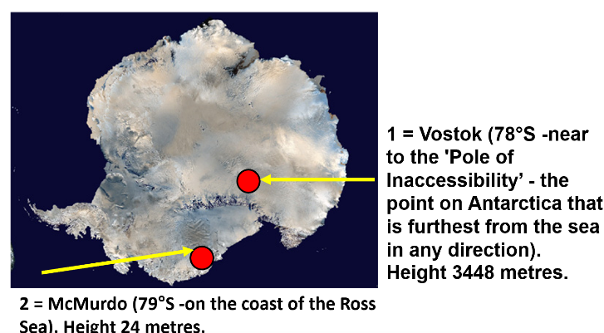
Image Source: Google Maps

