Polar climates
TEMPERATURE DATA (°C) FOR 3 RESEARCH STATIONS IN ANTARCTICA
 | Jan | Feb | Mar | Apr | May | Jun | Jul | Aug | Sep | Oct | Nov | Dec | Mean Annual temperature
1 Vostok | -32 | -44 | -58 | -65 | -66 | -65 | -67 | -68 | -66 | -57 | -43 | -32
2 Amundson-Scott | -28 | -41 | -54 | -57 | -57 | -58 | -60 | -60 | -60 | -51 | -38 | -28
3 McMurdo | 0 | -6 | -14 | -17 | -19 | -19 | -22 | -23 | -21 | -16 | -7 | -1

PRECIPITATION DATA (mm) FOR 3 RESEARCH STATIONS IN ANTARCTICA
 | Jan | Feb | Mar | Apr | May | Jun | Jul | Aug | Sep | Oct | Nov | Dec | Total
1 Vostok | 0.1 | 0 | 0.7 | 0.5 | 0.4 | 0.5 | 0.6 | 0.7 | 0.3 | 0.2 | 0.1 | 0
2 Amundson-Scott | 0.2 | 0.3 | 0 | 0 | 0.1 | 0 | 0 | 0 | 0.1 | 0 | 0 | 0.1
3 McMurdo | 15 | 21.2 | 24.1 | 18.4 | 23.7 | 24.9 | 15.6 | 11.3 | 11.8 | 9.7 | 9.5 | 15.7

- Calculate the mean annual temperature and the total precipitation for all 3 stations.
- Look at the temperature data – can you explain why it is so cold at all 3 stations referring back to what we have just learnt? ___________________________________________________________________________________________________________________
- Is there a lot of precipitation or a small amount?
- Look at the temperature and precipitation data. What happens to the amount of precipitation as the temperature falls?
- Could any of the information around the map help to explain this pattern?

Polar Weather – Can it be too cold to snow? Reasons why…

Complete the table by deciding why the factors might make it too cold for snow in Antarctica
Factors | Does this make Antarctica too cold for snow? How?
Moisture – areas close to the sea have more available moisture than those inland.
Evaporation – rates can be very slow from frozen ice sheets, oceans and the sea
Temperature: it has to be cold enough for the cloud droplets to grow as snowflakes and to not melt as they fall through the atmosphere and down to the ground.

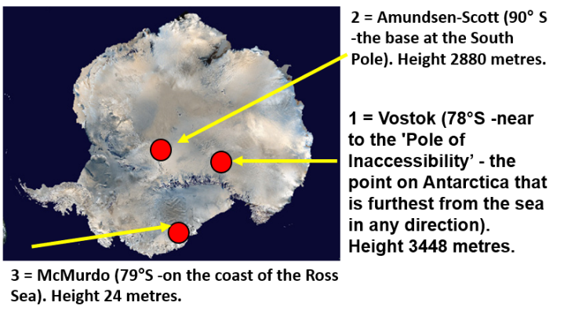

Image source: Google Maps

